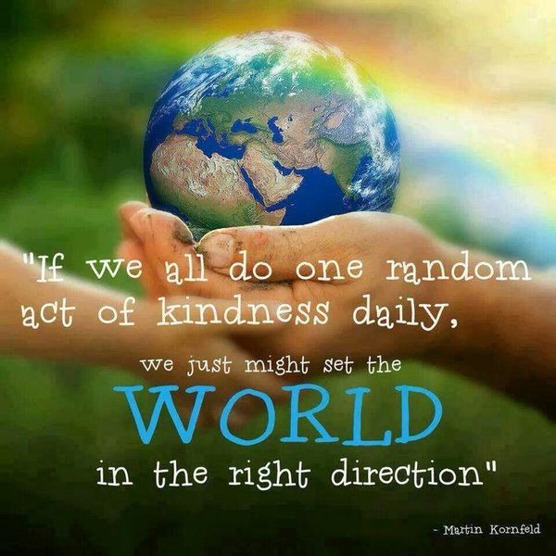

We Are All in This Together. . . Spreading Random Acts of Kindness and Hope During the Coronavirus Pandemic

My two sons played outside on Saturday with sidewalk chalk. They decided to write positive messages on the driveway and street to spread kindness and hope to people going on walks in our neighborhood. It prompted me to create this choice board of other activities for kids to continue this positivity.

**Challenge:** Try to do as many random acts of kindness below as you can to give people hope and help them realize that we are all in this together**! Remember to get a trusted adult’s permission before doing any of these and to follow the social distancing guidelines.** Feel free to e-mail me if you have other ideas for random acts of kindness and I will add them to the board. I’d love for you to share photographs of you spreading kindness via e-mail with me.

|  |  |  |  |  |
| --- | --- | --- | --- | --- |
| Write positive messages with sidewalk chalk on your driveway, sidewalk, or street. | Make a card or drawing for an elderly person. | Hang pictures, drawings, multimedia designs in your windows so that people can see something lovely when going for a walk. | Go outside and sing songs for people going on walks by your home. | Go outside and play musical instruments for people going on walks by your home. |
| Offer to take a neighbor’s dog for a walk in your neighborhood. Don’t go inside. | Leave a homemade note, card, or picture on a neighbor’s door. | Greet people that you see when going for a walk or bike ride. | Bring in the mail for an elderly neighbor. Leave it on their step. | Bring in the trash and/or recycling for an elderly neighbor to their yard. |
| Write a note or draw a picture thanking people in healthcare, 9-1-1 call center workers, and EMTs for taking care of people who are sick. | Write a note or draw a picture thanking police officers and people in law enforcement and fire-fighters for keeping people safe. | Write a note or draw a picture thanking farmers that produce food, factory workers that package and distribute that food, and truck drivers that transport those goods and food to our communities. | Write a note or draw a picture thanking grocery store and pharmacy clerks for keeping shelves stocked, ringing groceries, and staying open. | Write a note or draw a picture thanking your teachers and principals for providing you with distance learning activities. |
| Write a note or draw a picture thanking your parents or family member for helping you complete your distance learning work. | Write a note or draw a picture thanking the postal workers for delivering mail and packages. | Write a note or draw a picture thanking the sanitation workers for picking up trash and recycling. | Mail a note, send an e-mail, or call a family member to tell them you are thinking about them and miss them. | Mail a note, send an e-mail, or call a friend to tell them that you are thinking about them and miss them. |